**DevOps Assignment**

**1.GIT STASH:**

The git stash command takes your uncommitted changes , saves them away for later use, and then reverts them from your working copy. For example: At this point you're free to make changes, create new commits, switch branches, and perform any other Git operations; then come back and re-apply your stash when you're ready.

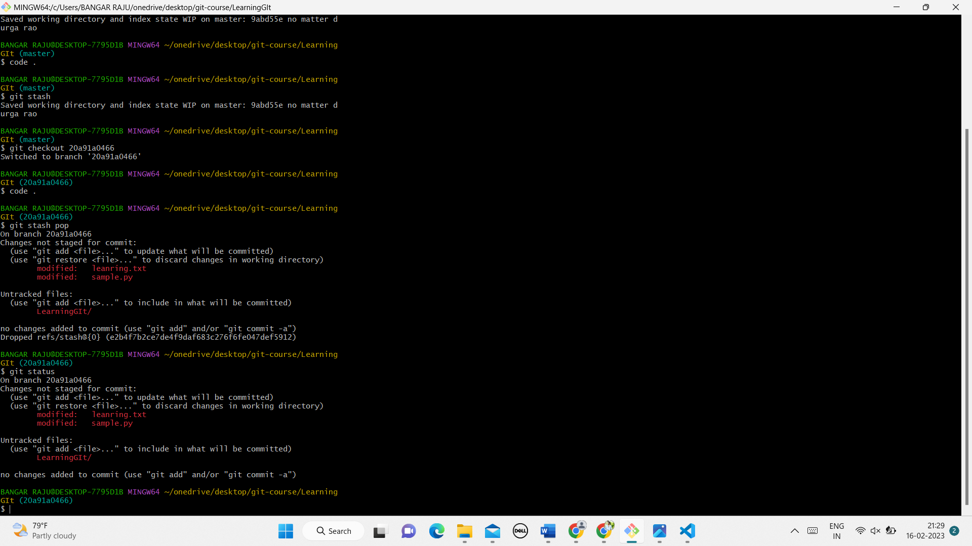

**2.1 GIT FETCH:**

Git fetch is a primary command used to download contents from a remote repository. git fetch is used in conjunction with git remote, git branch, git checkout, and git.

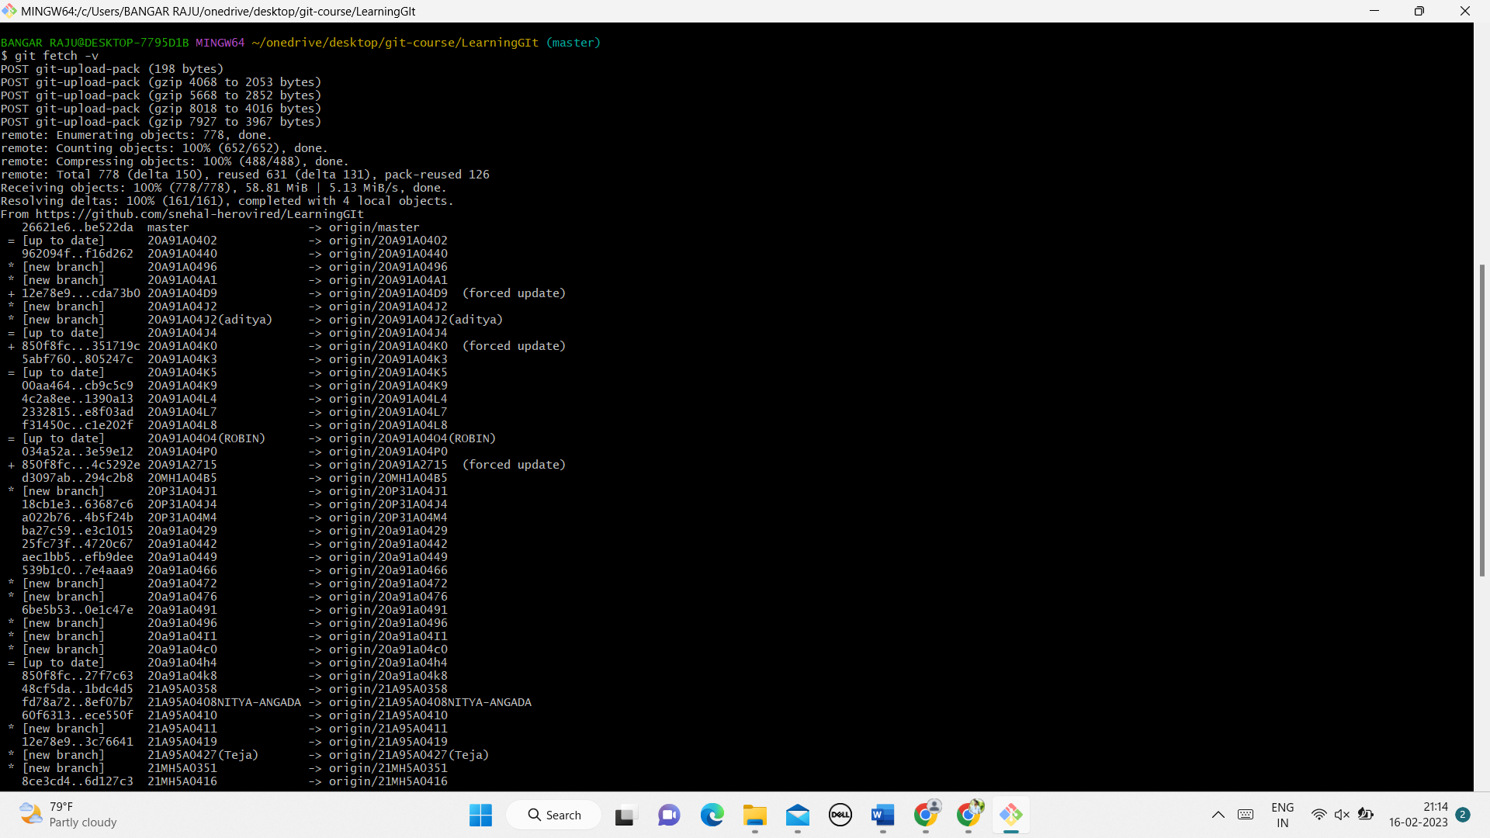

**2.2 GIT MERGE:**

The concept of git merging is basically to merge multiple sequences of commits, stored in multiple branches in a unified history or to be simple you can say in a single branch.

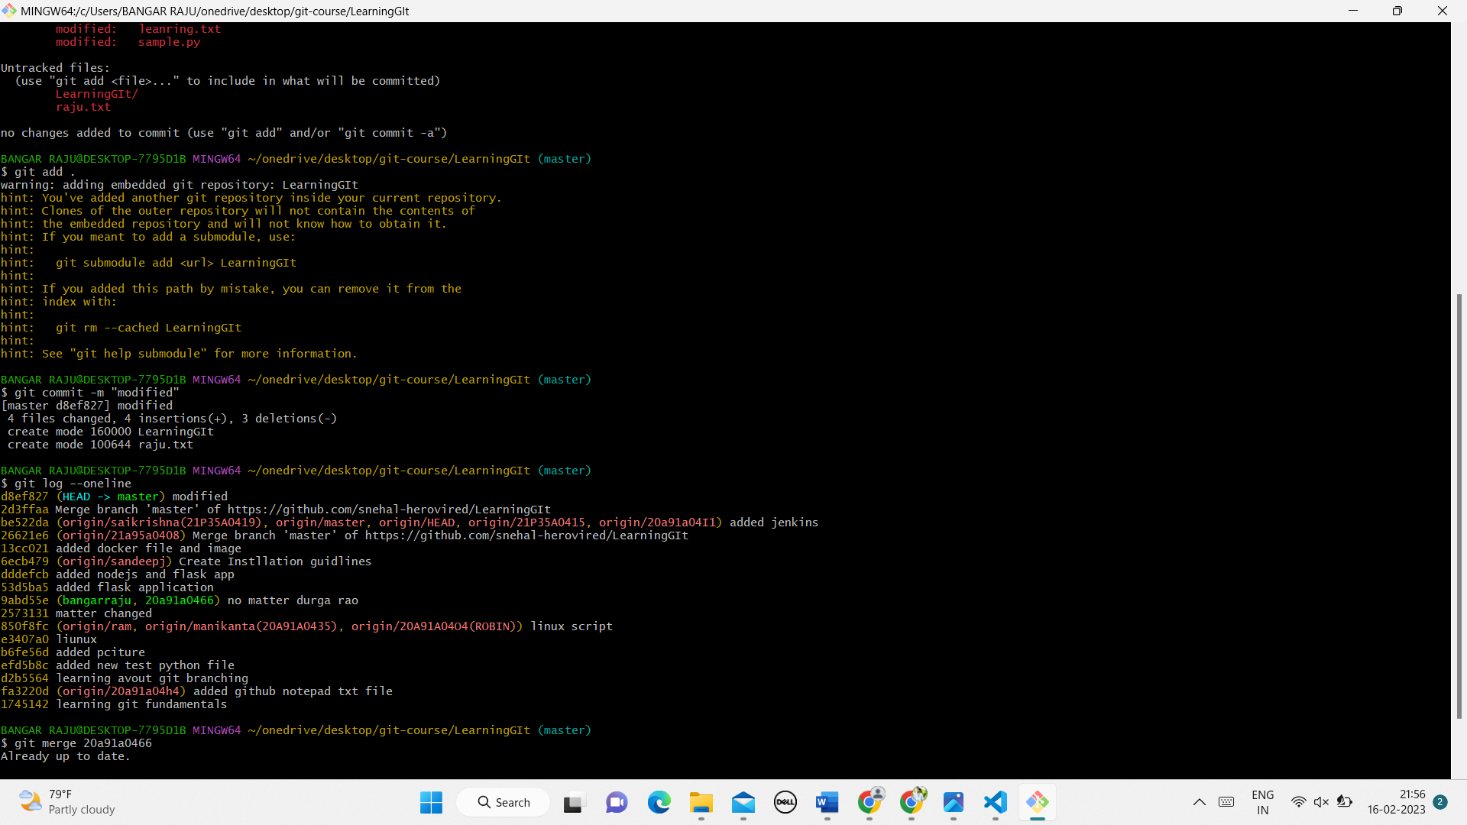

**3.DIFFERENCE BETWEEN GIT FETCH & GIT PULL:**

**3.1.GIT FETCH:**

Git fetch is a primary command used to download contents from a remote repository. git fetch is used in conjunction with git remote, git branch, git checkout, and git.



Fetch will never manipulate, destroy, or screw up anything. This means you can never fetch often enough.

**3.2. GIT PULL:**

Git pull command is used to download Git repository changes from a remote repository and merge those changes into our local repository. 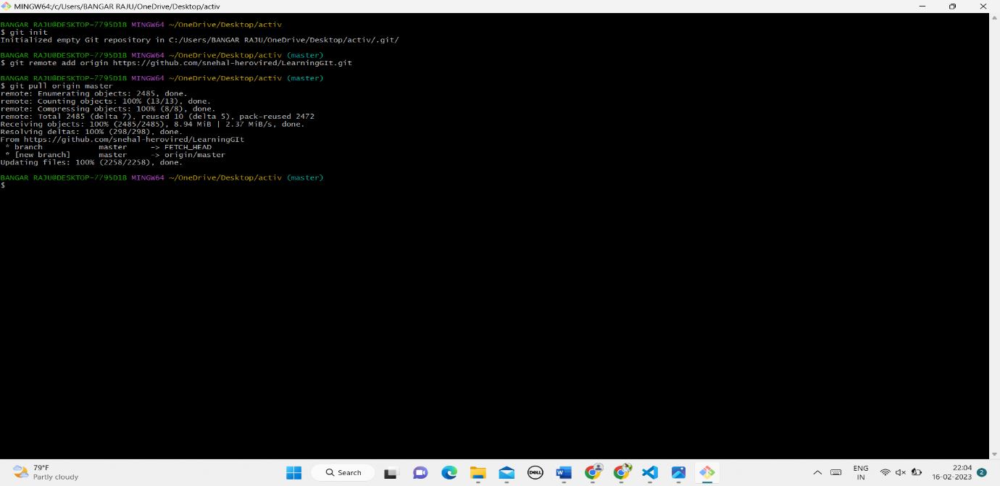

**4 .1. AWK COMMAND IN LINUX:**

The awk command is a Linux tool and programming language that allows users to process and manipulate data and produce formatted reports. The tool supports various operations for

advanced text processing and facilitates expressing complex data selections

Awk is mostly used for pattern scanning and processing.

It searches one or more files to see if they contain lines

that matches with the specified patterns and then perform the associated actions

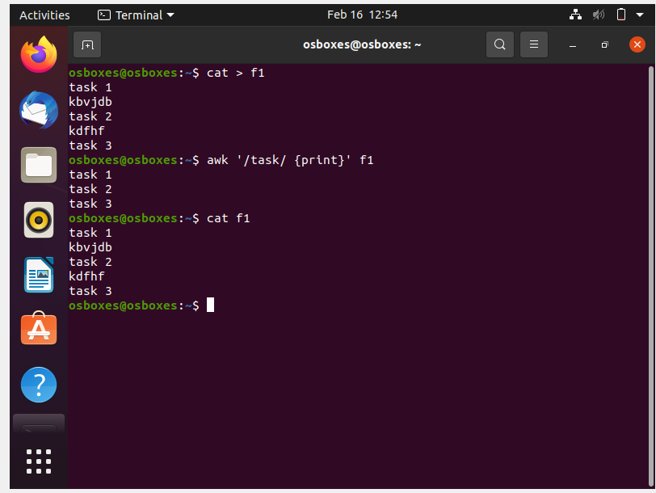

**4.2.BASH PROGRAM TO PRINT 1-20 PRIME NUMBERS:**

1.create a file using the Touch command.

2.edit the file using Nano file name command and write down the program

3.Run the file using Bash filename command.

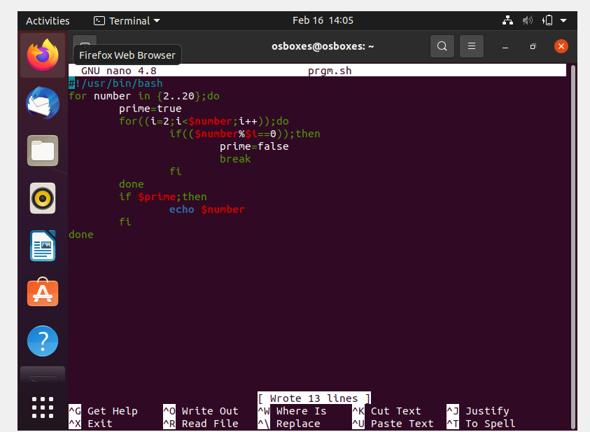

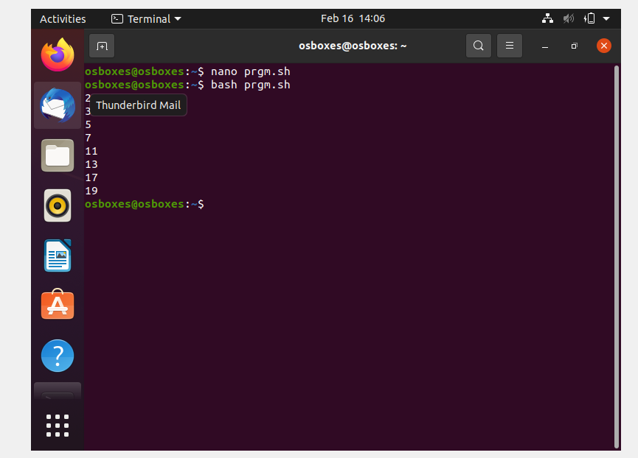

**5. SET UP A CONTAINER AND RUNNING UBUNTU OPERATING SYSTEM :**

